**Summer 2024: CS5720**

**Neural Networks & Deep Learning**

**ICP-2**

**Name: Madhu Kumar Sunkaraboina**

**#700 : 700745875**

**GitHub Link:**

**Video Link:**

1. Write a program that takes two strings from the user: first_name, last_name. Pass these variables to the fullname function that should return the (full name).
2. For example: ▪ First_name = “your first name”, last_name = “your last name” ▪ Full_name = “your full name”

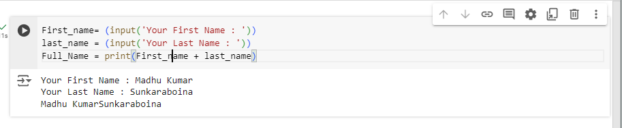

1. Write a function named “string_alternative” that returns every other char in the full_name string. Str = “Good evening”

Output: Go vnn

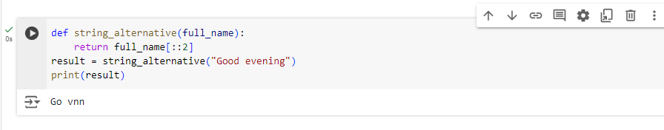

1. Write a python program to find the word count in a file (input.txt) for each line and then print the output. o Finally store the output in the output.txt file.

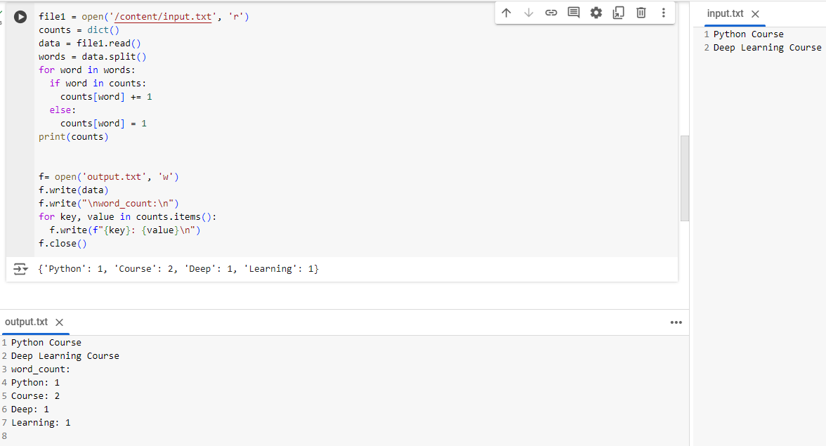

1. Write a program, which reads heights (inches.) of customers into a list and convert these heights to centimeters in a separate list using: 1) Nested Interactive loop. 2) List comprehensions

